Year 10
OLNA class

Quiz 7

2021

Statistics


Name: ______________________ Class: ______ Time: 20 minutes (strict) Total Mark:____/11

Resources: No calculator allowed

Question 1 4 marks

Complete the calculations for the following measures of central tendency for the data set below:
1, 5, 5, 7, 8, 10
Mean:

Median:

Mode:

Range:

Question 2 1 mark
Six members of a basketball team have the following heights:
205 cm, 205 cm, 196 cm, 194 cm, 190 and 186 cm

What is the median height?

A) 186cm B) 194cm C) 195cm D) 19cm

Question 3 1 mark
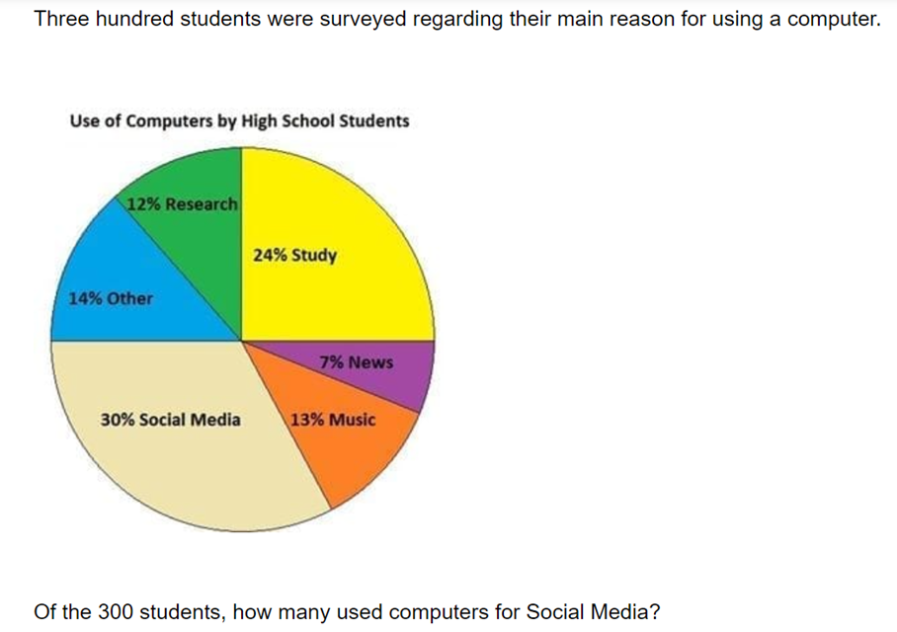

A) 30 B) 39 C) 60 D) 90 E) 130

Question 4 1 mark
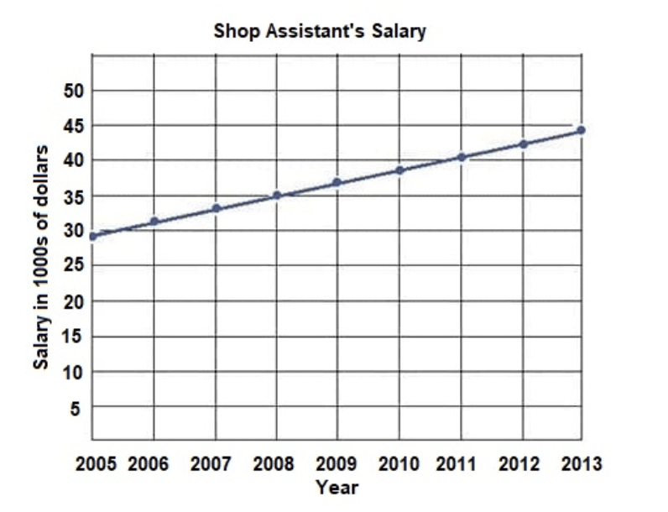
From the graph above, find the year that shop assistants were paid $38 000.

A) 2010 B) 2008 C) 2009 D) 2011
Question 5 4 marks
The results of a mathematics test are represented by this stem-and-leaf plot:
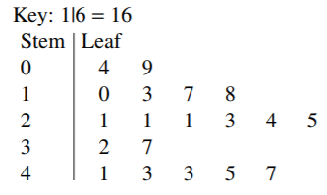

Find the mean, median, mode and range.

